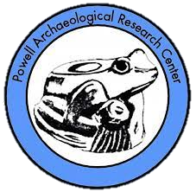
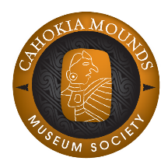
Cahokia Mounds Powell Archaeological
Museum Society Research Center
30 Ramey St. P.O Box 413
Collinsville, IL 62234 Columbia, IL 62236
www.cahokiamounds.org www.powellarchaeology.org
The Cahokia Mounds Museum Society (CMMS) and the Powell Archaeological Research Center (PARC) will host their annual Trivia Night and Silent Auction on Saturday, May 13, 2023, from 7pm-10pm. These two non-for-profit organizations are raising funds for the preservation and protection of archaeological sites in the Metro-East area.
We are seeking donations to be included in our silent auction or to be given away as prizes for our Trivia contest. Items could include tickets, gift certificates, merchandise, or gift baskets. All donations of cash or goods are tax deductible as the Cahokia Mounds Museum Society and the Powell Archaeological Research Center are both 501©(3) not-for-profit organizations. All donors will be acknowledged at the event.
The Trivia Night and Silent Auction will be held at the First United Presbyterian Church at 201 E. Church Street, Collinsville, Illinois 62234.
To donate an item for this event, please contact Linda Krieg at (618) 344-9221or giftshop@cahokiamounds.org. I will gladly pickup any items donated, and we can arrange a time that would be convenient for you.
Thank you for any help you may be able to give. We appreciate your support!
Sincerely,
Linda Krieg & Cricket Kelly
Cahokia Mounds Museum Society Powell Archaeological Research Center

-----------------------------------(Please copy for your records and return)--------------------------------

ITEM DONATED: _____________________________________________________________
APPROX. RETAIL VALUE: ____________ SUGGESTED STARTING BID: ____________
DESCRIPTION/RESTRICTIONS: ________________________________________________
_____________________________________________________________________________
COMPANY/ORGANIZATION: __________________ CONTACT PERSON: ____________
ADDRESS: _________________________ CITY, ST, ZIP: ____________________________
PHONE: ______________________ EMAIL: _______________________________________

Submit this form by:
Fax: (618) 346-5162 | Phone: (618) 344-9221 | Email: giftshop@cahokiamounds.org
Mail: 30 Ramey Street, Collinsville, Illinois, 62234

